|  |
| --- |
| SPEAR News  June 2020 |

**Message to our stakeholders**

We have all been living and working in unprecedented times due to the COVID-19 pandemic. The SPEAR team truly hope all our users and stakeholders continue to stay safe.

|  |
| --- |
| Key dates:  SPEAR Release 5.1 is due for release August 2020  SPEAR release 5.2 is due for release December 2020 |

# Milestone - SPEAR Electronic Lodgment Network

The SPEAR team reached a significant milestone in early May signing up 300 lodging parties to the SPEAR Electronic Lodgment Network (ELN). This milestone was quickly eclipsed as there are now 358 subscribers (legal practitioners and conveyancers) with a further 398 applications in progress.

It is amazing to reflect that in early April there were 250 ELN subscribers, with the increase been clearly due to the combination of continued marketing of the system and the recent closure of 2 Lonsdale Street due to COVID-19.

The increase in ELN subscribers has led to an increase in the level of lodgments in the past few months as shown below:

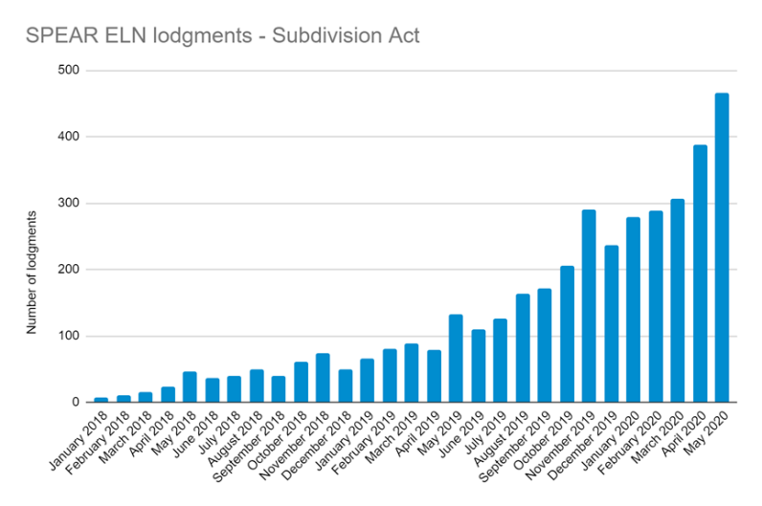

The SPEAR team is now conducting weekly online group training sessions for all new ELN subscribers. If you wish to attend a session contact the SPEAR Service Desk.

A complete list of [SPEAR ELN organisations](https://www.spear.land.vic.gov.au/spear/spearOrganisations/List.do) is on the SPEAR website.

## Lodging fees from 1 July 2020 – no change

In accordance with *Monetary Units Act 2004*, the Treasurer has fixed the value of a fee unit for the financial year commencing 1 July 2020. The fee remains unchanged from the current financial year at $14.81. From 1 July 2020, the fees for lodging transactions at Land Use Victoria remain the same.

Comprehensive fee listings and fee calculators are at <https://www.propertyandlandtitles.vic.gov.au/forms-guides-and-fees/fees.>

# SPEAR signing application rollout to resume

A new version of the SPEAR signing application was released on 1 June 2020 to resolve an issue affecting users of some third-party security software. Around 200 organisations are using the new signing application and will be prompted to download the new version when they next sign, if they haven’t already done so. With the release of this new version, the SPEAR team can continue the rollout to remaining organisations.

Users that are still using Java for digital signing will be migrated to the new signing application over the next few months. Affected organisations will be notified prior to their scheduled transition by email and broadcast message. This change only impacts users that have a digital signing role in SPEAR.

Please contact the SPEAR Service Desk on (03) 9194 0612 if you have any issues installing the new signing application.

# SPEAR modernisation - Angular project

The SPEAR Angular project has been undertaken to modernise SPEAR. Angular is a web development framework that is being adopted ensuring SPEAR is using best practice IT technologies and infrastructure.

SPEAR screens are being rebuilt to adopt this new framework. Noting there are no proposed changes to functionality at this time.

The Electronic Subdivisions Unit is working with the Victorian Land Registry Services to ensure there is minimal impact to SPEAR users.

There are two phases scheduled for the implementation of the Angular project:

* Phase 1 – due for release July 2020
* Phase 2 – due for release October 2020

# SPEAR website refresh

The homepage of the website has been updated to reflect the addition of our fourth key stakeholder group, SPEAR lodging parties.

This change will direct lodging party users to relevant information on how to become a subscriber and lodge a plan, and importantly access to video tutorials to assist in their training and ongoing use of the system.

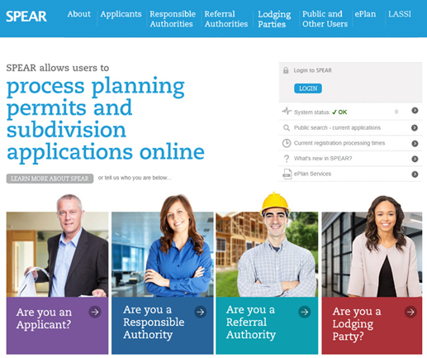

# Melbourne Strategic Assessment program

MSA The *Melbourne Strategic Assessment (Environment Mitigation Levy) Act 2020* comes into effect on 1 July 2020. The new legislation requires councils issuing a Statement of Compliance for a subdivision of levy-affected land to provide a copy of the Statement of Compliance and Plan of Subdivision to the Secretary to the Department of Environment, Land, Water and Planning (DELWP) for assessment.

An enhancement to SPEAR to help support the Melbourne Strategic Assessment program is due to be implemented in SPEAR Release 5.1, currently scheduled for September 2020. Until then, affected councils will need to ensure they provide this information to DELWP manually.

For more information on Melbourne Strategic Assessment program, please visit <https://www.msa.vic.gov.au/>

# ePlan release

An ePlan release has been scheduled for August and includes the following enhancements:

Data Viewer service version 3.0

* Improved functionality to viewing ePlan data contained in the LandXML file
* Embedding 10 Quick Tours that provides demonstration of the Data Viewer functions
* Enhancement to the Validation Report that associates any validation errors / warnings with the ePlan data on the screen
* Integrating the Visualisation Enhancement Tool (VET) into the Data Viewer service
* Provision to download LandXML files

VET service version 4.1

* Enhanced functionality to associate diagram label enlargements to the main plan diagram
* Ability to adjust the value of the bearing labels +/- 180 degrees

Visualisation service version 4.1

* General improvements to cater better for complex plans

Validation service version 5.1

* General minor improvements

# Digital Cadastre Modernisation project

The Digital Cadastre Modernisation project is progressing well. Upgraded data is making its way through the production pipeline and proposed dates will soon be released when the enhanced data will be available for Vicmap users.

In the meantime, please visit the [DCM website](https://www2.delwp.vic.gov.au/maps/dcm/frequently-asked-questions) if you’re curious to know about questions that have been asked about the project. Some of these questions were first raised at SPEAR User Group meetings in 2019 and will continue to be added to as your feedback is gathered about the development and release of the digital cadastre.

1. **Reviewing Victoria’s naming rules**

Geographic Names Victoria is reviewing the Naming rules for places in Victoria 2016 (‘the naming rules’) as provided under Section 6 of the *Geographic Place Names Act 1998.* The 2020 review will see several amendments and improvements. The current naming rules are [here](https://urldefense.proofpoint.com/v2/url?u=https-3A__www.vision6.com.au_ch_77298_17tc0_2199375_.3MJazpZ-5FRha97GCZsHo6T9cXWf1QMcd6yNi6vHk.html&d=DwMCAw&c=JnBkUqWXzx2bz-3a05d47Q&r=wITQGj0XGMC3IqhNCyBf0pfpkZ9NLKxmD8v_1UmVSJ0&m=ii64CEhWh8m4NAg2pqfUEqr4qYcTuDSUzN-tx84kGh8&s=24eyd9IgVE2gAjMWMFwvIEpxT7hYgzUn_yWf_Aah0dw&e=).   
  
The team are looking forward to engaging with stakeholders throughout the review, which will begin next month - stay tuned for more information. A 2020 Naming rules review committee is being established to ensure comments and proper governance of the review. The nominated committee members include members of the Geographic Place Names Advisory Panel, colleagues from emergency services and representatives from councils. It is expected that the Committee will consider matters on a monthly basis.  
  
Council officers interested in sitting on the 2020 Naming rules committee should contact [Rafe Benli](mailto:geo.names@delwp.vic.gov.au).

# Handy Hints

## Digital certificate backup from Internet Explorer

For SPEAR signing users who have digital certificates installed directly to their computer, creating a backup of these certificates so that they can be installed and used on other PCs has been particularly useful over the last few months with many adapting to work from home arrangements.

With ongoing flexibility in mind, this process should be revisited to ensure a smooth transition back to office-based work. Particularly if office-based system upgrades have taken place which may have affected certificates in the workplace.

To back up your digital certificate:

1. Open a new browser window in **Internet Explorer**: Go to the Tools menu at the top right, select ‘Internet Options**’**, then go to the Content tab, and click ‘Certificates’.
2. Your Gatekeeper certificates will be displayed in the Personal tab.  You will need to identify the two certificates with the most current expiry date, and export both the Signing and Encryption certificate. Start by double-clicking on the first certificate. **DO** **NOT** choose the ‘Import…’ option.

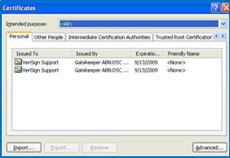

1. From the Certificate window go to the Details Tab. Scroll to the bottom of the list and click on the field item called ‘Key Usage’. As the certificates appear to be identical, you will need to identify each one by its description within the Key Usage row value. The Signing certificate will hold the value ‘Digital Signature, Non-Repudiation’, the Encryption certificate will hold the value ‘Key Encipherment, Data Encipherment’. Once the field is highlighted blue, click ‘Copy to File’.   
      
   **NOTE: Remember which certificate you're backing up - it will assist when choosing a filename for your backup in Step 7.**
2. The Certificate Export Wizard will now open.  Click ‘Next’ on the first screen, then select ‘Yes, export the private key’ on the second screen.

The Export File Format selection allows you to modify how the certificate is exported. Under the Personal Information Exchange section make sure that you **DO NOT** select the ‘Delete the private key if the export is successful’ option. Everything else under this section should be selected. Once they have been selected, click ‘Next’.

**NOTE: The options available may vary across computers.**

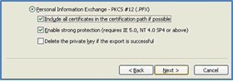

1. Choose a password for security of your backed-up certificate.  Use at least one uppercase and one non-alphabetic character and preferably 8 characters. Securely record your password for future reference. **It cannot be recovered or changed!**
2. Choose a location and name for your backed-up certificate.    
      
   **NOTE: Suggested filenames for your backed-up certificates are ‘Freds signing cert2009’ and ‘Freds encryption cert2009’.**
3. Depending on the security level that you have when enrolling for your certificate, you may be presented with a box asking for a ‘CryptoAPI Private Key’ password - this is the password you chose when you enrolled.  **NOTE: Neither Gatekeeper or SPEAR can recover or reset this password for you!**  High Security requires a password. Medium security does not require a password.
4. **You need to repeat the backup process for the other certificate***.* Go back to Step 2 of this User Guide, select the second certificate and repeat the backup process.

If you wish to ensure that your digital certificates have been backed up correctly into your selected folder, look for two files with .pfx extensions.

More detailed instructions with screenshots of this process can be found on the SPEAR website in [User Guide 33A – Installing and backing up your digital certificates in Internet Explorer](https://www.spear.land.vic.gov.au/spear/documents/UserGuide33A_Installing%20DC.pdf).

## Lodging Parties - OC Forms in SPEAR

SPEAR ELN users will notice a difference in SPEAR when it comes to the provision of the OC1 or OC2 Forms to support plan lodgments.

Some applications will display a mandatory action for the user to supply the OC1 or OC2 Form, yet other applications, which clearly show an OC schedule on the plan PDF are not prompting for the relevant form via mandatory action.

Why is this the case? The reason SPEAR shows a mandatory action in some cases but not in others, is the way that the surveyor provided the OC data in SPEAR in the first place.

Up until 1/01/2020* surveyors had the option to either provide OC data on the plan, or on an Excel spreadsheet. The Excel spreadsheet provides more scope for using the underlying data and allows SPEAR to auto-generate the OC Forms and present mandatory actions to the lodging party to review/edit prior to signing.

If the surveyor has not used the excel spreadsheet and has instead provided the OC schedule on the PDF plan, then SPEAR cannot pre-populate the OC Form. In these cases, the onus is on the lodging party to recognise the requirement for preparing an OC1 or OC2 Form, and instead select the option from the list of optional actions in SPEAR.

**\* NOTE: Version 7 of the Registrar's Requirements for Paper Conveyancing Transactions stipulates that from 01/01/2020, OC information must be provided by the surveyor using the Excel spreadsheet template available in SPEAR.**

### Application Example 1:

Mandatory action for the lodging party to supply the OC1 Form, when the OC data was provided in a spreadsheet by the surveyor.

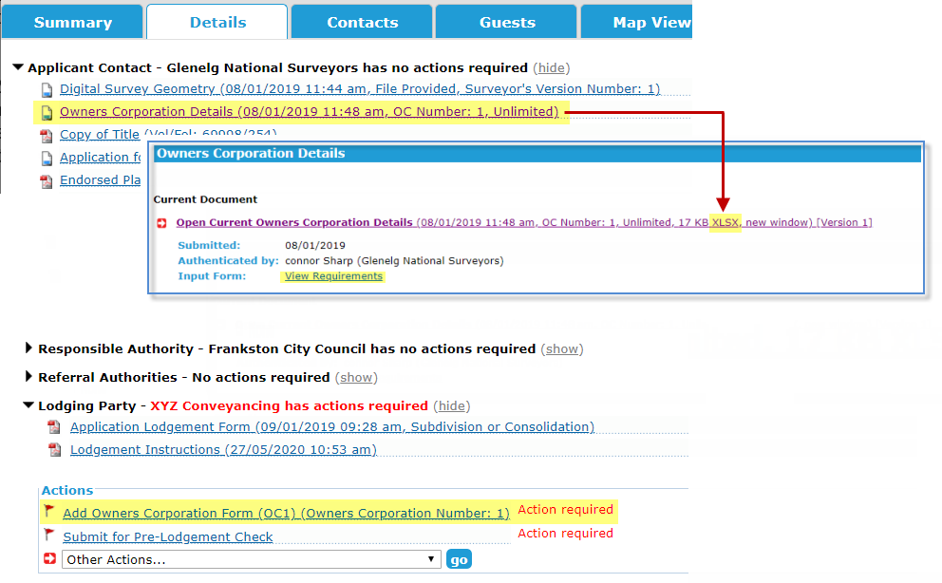

### Application Example 2:

Optional action for the lodging party to supply the OC1 Form, when the owners corporation was supplied with the plan PDF by the surveyor.

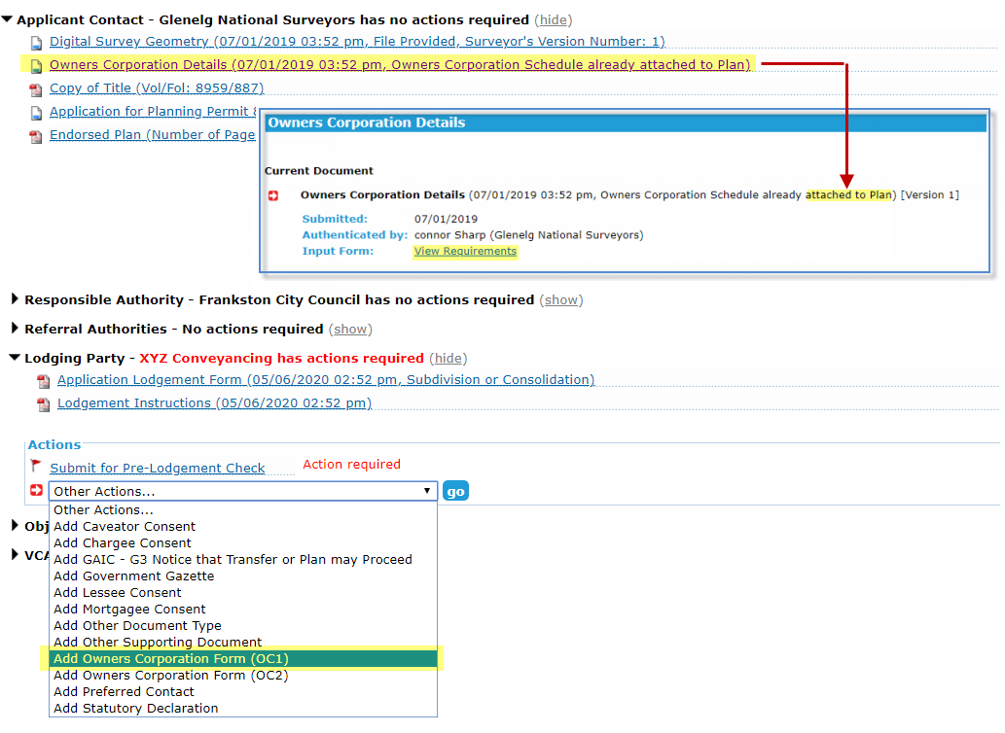

# Training

The following dates have been scheduled for our quarterly training sessions. These sessions will continue to be held online and if you wish to attend a session, please register by contacting the SPEAR Service Desk on (03) 9194 0612.

### Applicant Contact

Tuesday 11 August, Tuesday 10 November

### Statutory referral authority

Tuesday 11 August, Tuesday 10 November

### Responsible Authority – councils

Tuesday 4 August, Tuesday 17 November

* Non-statutory referral authority- internal council department

Tuesday 4 August

# Support

SPEAR wants to ensure your questions and issues are resolved quickly.

Contact the SPEAR Service Desk on (03) 9194 0612

* Press 1 for SPEAR assistance
* Press 2 for Land Use Victoria subdivision lodgment enquiries
* Press 3 for ePlan enquiries

Alternatively, you can send your enquiry by email to [spear.info@delwp.vic.gov,au](mailto:spear.info@delwp.vic.gov,au)

|  |
| --- |
| Contact SPEAR  **T:** 03 9194 0612  **E:** spear.info@delwp.vic.gov.au  **W:** www.spear.land.vic.gov.au |

This line of text is essential for formatting. Keep all content above this instruction text line. This text will not appear on your document.

|  |  |
| --- | --- |
| © The State of Victoria Department of Environment, Land, Water and Planning 2021  LogoThis work is licensed under a Creative Commons Attribution 4.0 International licence. You are free to re-use the work under that licence, on the condition that you credit the State of Victoria as author. The licence does not apply to any images, photographs or branding, including the Victorian Coat of Arms, the Victorian Government logo and the Department of Environment, Land, Water and Planning (DELWP) logo. To view a copy of this licence, visit http://creativecommons.org/licenses/by/4.0/  Disclaimer  This publication may be of assistance to you but the State of Victoria and its employees do not guarantee that the publication is without flaw of any kind or is wholly appropriate for your particular purposes and therefore disclaims all liability for any error, loss or other consequence which may arise from you relying on any information in this publication. | Accessibility  If you would like to receive this publication in an alternative format, please telephone the DELWP Customer Service Centre on 136186, email [customer.service@delwp.vic.gov.au](mailto:customer.service@delwp.vic.gov.au), or via the National Relay Service on 133 677 [www.relayservice.com.au](http://www.relayservice.com.au). This document is also available on the internet at [www.spear.land.vic.gov.au](http://www.spear.land.vic.gov.au). |